Home Work 1

1-1 Figure 21-39 shows a long, nonconducting, massless rod of length L, pivoted at its center and balanced with a block of weight W at a distance x from the left end. At the left and right ends of the rod are attached small conducting spheres with positive charges q and 2q, respectively. A distance h directly beneath each of these spheres is a fixed sphere with positive charge Q. (a) Find the distance x when the rod is horizontal and balanced. (b) What value should h have so that the rod exerts no vertical force on the bearing when the rod is horizontal and balanced? (HRW21-44)

1-2 In Fig. 21-42, two tiny conducting balls of identical mass m and identical charge q hang from nonconducting threads of length L. Assume that θ is so small that tanθcan be replaced by its approximate equal, sinθ. (a) Show that
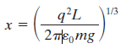
gives the equilibrium separation x of the balls. (b) If L =120 cm, m = 10 g, and x = 5.0 cm, what is |q|?. (HRW21-55)
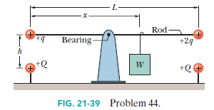
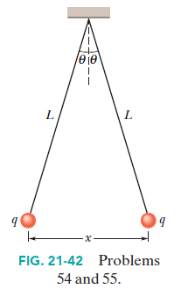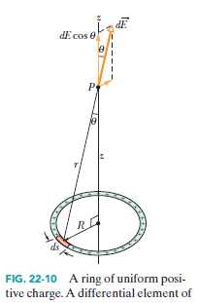

1-3 An electron is constrained to the central axis of the ring of charge of radius R in Fig. 22-10, with z << R. Show that the electrostatic force on the electron can cause it to oscillate through the ring center with an angular frequency
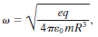
where q is the ring’s charge and m is the electron’s mass. (HRW22-76)

1-4 In Fig. 22-51, positive charge q = 7.81 pC is spread uniformly along a thin nonconducting rod of length L = 14.5 cm. What are the (a) magnitude and (b) direction (relative to the positive direction of the x axis) of the electric field produced at point P, at distance R = 6.00 cm from the rod along its perpendicular bisector? (HRW21-32)

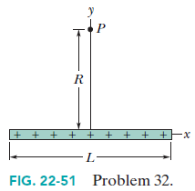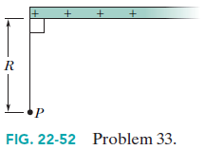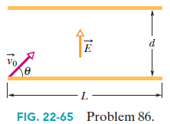

1-5 In Fig. 22-52, a “semi-infinite” nonconducting rod (that is, infinite in one direction only) has uniform linear charge density. Show that the electric field E_{p} at point P makes an angle of 45° with the rod and that this result is independent of the distance R. (Hint: Separately find the component of E_{p} parallel to the rod and the component perpendicular to the rod.) (HRW22-33)

1-6 In Fig. 22-65, a uniform, upward electric field E of magnitude 2.00 × 10³ N/C has been set up between two horizontal plates by charging the lower plate positively and the upper plate negatively. The plates have length L = 10.0 cm and separation d = 2.00 cm. An electron is then shot between the plates from the left edge of the lower plate. The initial velocity v₀ of the electron makes an angle θ = 45.0° with the lower plate and has a magnitude of 6.00 = 10⁶ m/s. (a) Will the electron strike one of the plates? (b) If so, which plate and how far horizontally from the left edge will the electron strike?? (HRW22-86)

